Aman Patel

STAT-S 350

October 14, 2020

Problem Set 4

1. Find expected value, median, IQR,
   * 1. Expected value
 $\int_{0}^{1}{0.3x dx}+ \int_{1}^{2}{0.7x dx}$

 $\left(0.15*1^{2}-0.15*0^{2}\right)+\left(0.35*2^{2}-0.35*1^{2}\right)$

 $0.15+1.4-0.35=1.2$

  2. Median
 $\int_{0}^{a}{f\left(x\right) dx}=\frac{1}{2}$

 $\int_{0}^{1}{0.3 dx}+\int_{1}^{a}{0.7 dx}=\frac{1}{2}$

 $\left(0.3*1-0.3*0\right)+\left(0.7*a-0.7*1\right)=\frac{1}{2}$

 $0.3+0.7a-0.7=\frac{1}{2}$

 $0.7a=0.9$

$a=\frac{0.9}{0.7}=\frac{9}{7}=1.285714$

3. IQR
 $\int_{0}^{Q1}{f\left(x\right) dx}=\frac{1}{4}$

 $Q1=\frac{0.25}{0.3}=\frac{5}{6}=0.83333$

 $\int_{0}^{Q3}{f\left(x\right) dx}=\frac{3}{4}$

 $Q3=1+\frac{0.45}{0.7}=1\frac{9}{14}≈1.642857$

 $IQR=Q3-Q1=\frac{17}{21}≈0.809523$

$P\left(0.5<X<1.5\right)$

$\int_{0.5}^{1.5}{f\left(x\right) dx}$

$\int_{0.5}^{1}{0.3 dx}+\int_{1}^{1.5}{0.7 dx}$

$\left(0.3*1-0.3*0.5\right)+\left(0.7*1.5-0.7*1\right)$

$0.15+0.35=0.5$

$f\left(x\right)= \left\{\begin{aligned}2\left(x-1\right) 1≤x≤2 \\ 0 otherwise\end{aligned}\right.$

4. Expected value
 $\int_{1}^{2}{2x^{2}-2x dx}$

 $\int_{1}^{2}{2x^{2} dx}-\int_{1}^{2}{2x dx}$

 $\frac{2}{3}\left(2^{3}-1^{3}\right)-\left(2^{2}-1^{2}\right)$

 $\frac{14}{3}-3=\frac{5}{3}=1.66666$

 5. Median
 $2\int_{1}^{a}{x dx}-2\int_{1}^{a}{1 dx}=\frac{1}{2}$

 $\left(a^{2}-1^{2}\right)-2\left(a-1\right)=\frac{1}{2}$

 $a^{2}-2a+\frac{1}{2}=0$

 $a=\left\{0.293, 1.707\right\}$

 $a≥1, a=1.707$

6. IQR
 $\int_{1}^{Q1}{2x dx}-\int_{1}^{Q1}{2 dx}=\frac{1}{4}$

 $\left(Q1^{2}-1^{2}\right)-2\left(Q1-1\right)=\frac{1}{4}$

 $Q1^{2}-2Q1+\frac{3}{4}=0$

$\left(Q1-\frac{3}{2}\right)\left(Q1-\frac{1}{2}\right)=0$

$Q1=\left\{0.5, 1.5\right\}$

$1≤Q1≤2, Q1=1.5$

$\int_{1}^{Q3}{2x dx}-\int_{1}^{Q3}{2 dx}=\frac{3}{4}$

$\left(Q3^{2}-1^{2}\right)-2\left(Q3-1\right)=\frac{3}{4}$

$Q3^{2}-2Q3+\frac{1}{4}=0$

$Q3=\left\{0.134, 1.866\right\}$

$1≤Q3≤2, Q3=1.866$

$IQR=Q3-Q1= 0.366$

$P\left(0.5<X<1.5\right)$

$\int_{0.5}^{1.5}{f\left(x\right)dx}$

$\int_{0.5}^{1}{0 dx}+\int_{1}^{1.5}{2x dx}-\int_{1}^{1.5}{2 dx}$

$0+\left({1.5}^{2}-1^{2}\right)-2\left(1.5-1\right)$

$1.25-1=0.25$

$X \sim Uniform\left(5,15\right)$

1. Find $\frac{IQR\left(X\right)}{σ(X)}$
 $IQR\left(X\right)=12.5-7.5=5$

 $σ\left(X\right)=\sqrt{VarX}=15$

 $\frac{IQR\left(X\right)}{σ\left(X\right)}=\frac{5}{15}=\frac{1}{3}$

2. Find $\frac{IQR\left(Y\right)}{σ\left(Y\right)}$
$IQR\left(Y\right)=qnorm\left(0.75,10,15\right)-qnorm\left(0.25,10,15\right)=20.2347$

$σ\left(X\right)=\sqrt{VarX}=15$

$\frac{IQR\left(Y\right)}{σ\left(Y\right)}=\frac{20.2347}{15}≈1.34898$

2. Create functions in R
   1. 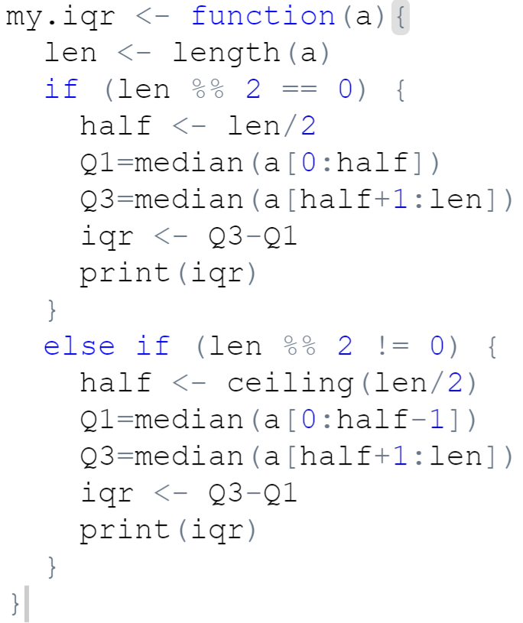

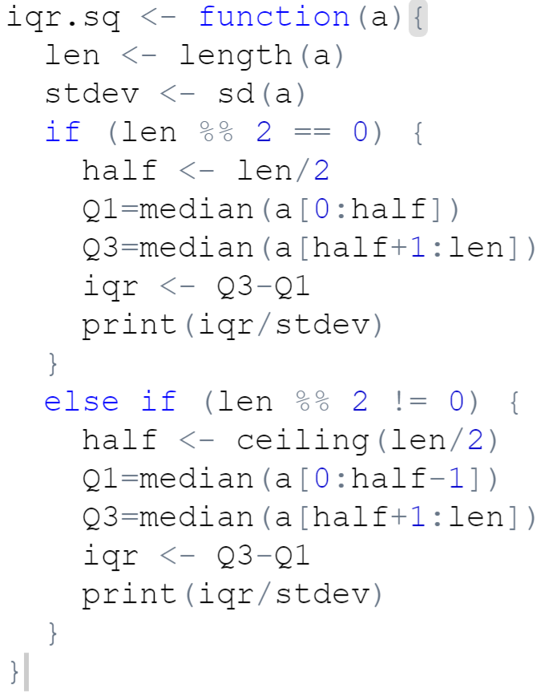

1. Peruvian Indian pulse rates
   1. Plug-in mean and variance
      1. Mean: $70.30769$
      2. Variance: $87.90533$
   2. Plug-in median and IQR
      1. Median: $72$
      2. IQR: $76-64=12$
 $\frac{12}{\sqrt{87.90533}}=1.27989$

  3. 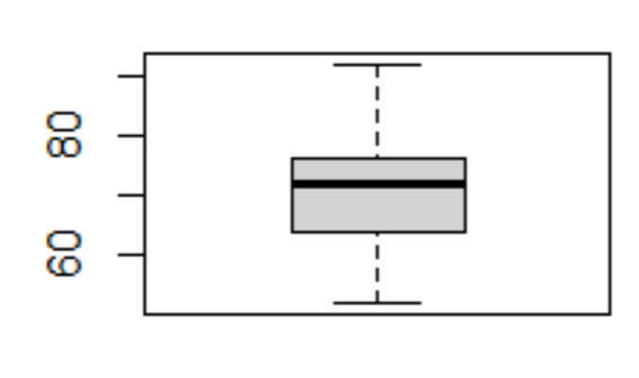Boxplot

* 1. 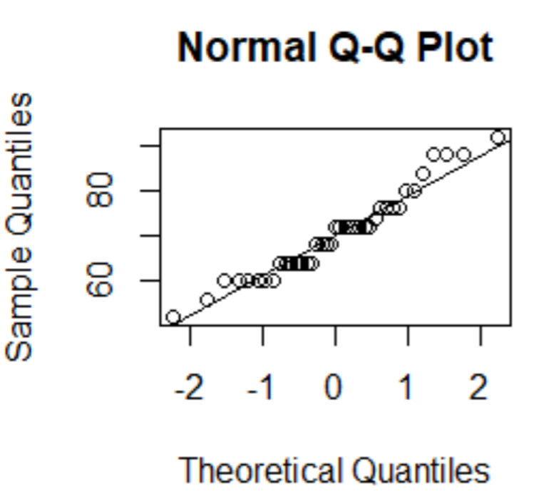Normal probability plot
  2. Kernel density plot

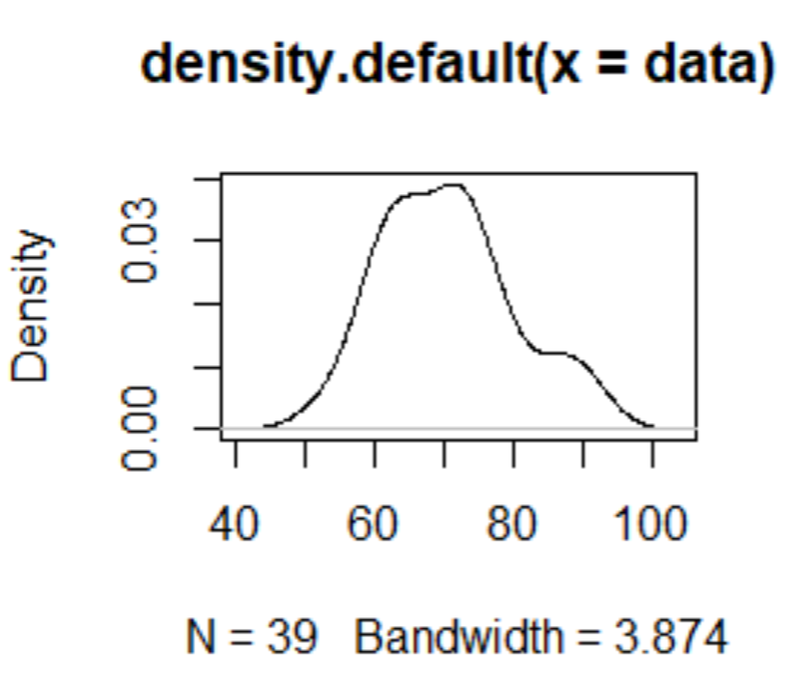

* 1. Yes, the data follows the qqline accurately and the kernel density graph resembles a normal distribution

1. Trosset 7.7.4
   1. Plug-in estimates
      1. Mean: $1.4876$
      2. Variance: $2.787554$
      3. Median: 1.076
      4. IQR: $1.2815$
   2. $\sqrt{2.787554}=1.6696>1.2815∴$ not normal
   3. 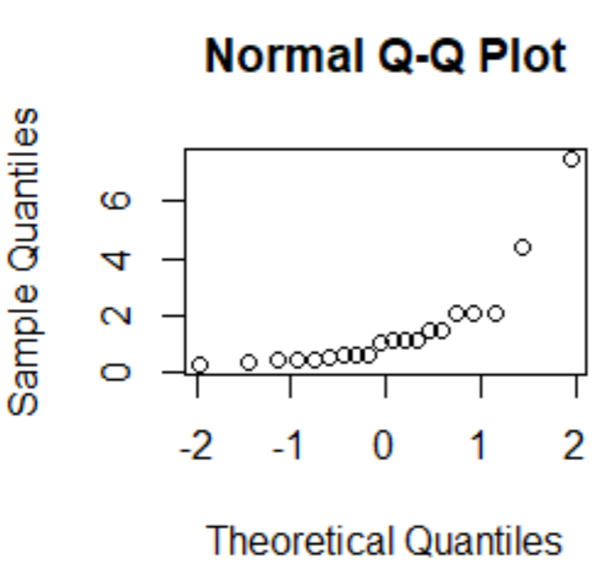Normal probability plot, not normal because the plot does not resemble a straight, increasing line
   4. After logging the values, the normal probability plot resembles a straight line, y was drawn from a normal distribution